DRAFT

FINAL DRAFT

**Narooma and District Community Plan 2020**

**How life should be**

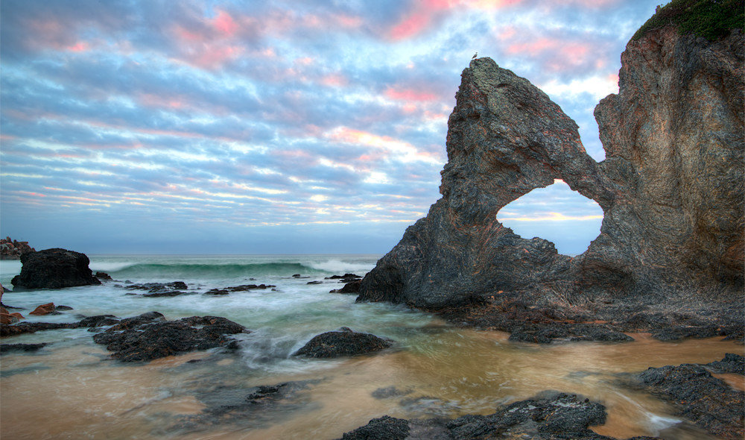

|  |
| --- |
| **2019-20 Bushfire Season and COVID-19 impacts on this Community plan**  In the beginning of December 2019, events began to unfold that that would significantly impact the Narooma District. A bushfire, somewhat common during this time of year, forced the closure of a major road accessing the district. As tourism is the major industry that supports most businesses, closing a major transport route into the area during one of the peak visitor months was an issue. But in isolation, the issue was manageable.  However, the situation worsened progressively and culminated in a forced evacuation of all visitors from the Narooma District in the lead up to the New Year. Narooma became surrounded by bushfire with the only open escape route out onto the beach and into the ocean. Fortunately, the disaster did not lead to this outcome. The Narooma District did not suffer the destructive wrath of the bushfires like neighbouring communities of Mogo or Cobargo.  The bushfires burned well into January and the well-publicised disaster meant that no visitors could visit during the peak December to January period. Without visitors in the district, many businesses went without customers and lost the revenue from their busiest time of year. Well beyond the significant and very real economic implications is the personal and community trauma that was suffered.  While the disaster has changed the region, the community is resilient and remains positive regarding the future. It is the intention of this plan to provide initiatives that will directly benefit the community and the many businesses that have been affected by the disaster. While this plan includes elements of recovery, it remains about the long-term growth, development and evolution of our district.  **Coronavirus / COVID – 19 Outbreak**  The outbreak of coronavirus will amplify the economic issues and hardships experienced by businesses and the community at large. The initiatives in this Community Plan are now immediately required (plus additional assistance from Government, industry and the people of Australia). |
|  |

Acknowledgement of Country

We recognise the Yuin people as the original inhabitants and custodians of all land and water within the Narooma District and respect their enduring cultural and spiritual connection to country. We pay respect to their Elders past, present and emerging.

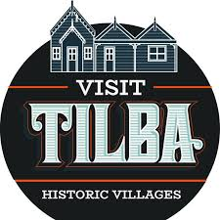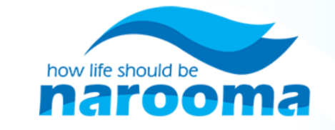Our Sponsors

**Table of Contents**

[1 Introduction](#_Toc36052448) 2

[2 About Our District](#_Toc36052449) 3

[3 Our Investigations 5](#_Toc36052450)

[4 Community Engagement 7](#_Toc36052451)

[5 Our Future 8](#_Toc36052452)

[5.1 Our Competitive Position 8](#_Toc36052453)

[5.2 Our Vision 9](#_Toc36052454)

[5.3 Our Principles](#_Toc36052455) 9

[5.4 Our Big Ideas 1](#_Toc36052456)0

[6 Our Plan 12](#_Toc36052457)

[6.1 Overview 12](#_Toc36052458)

[6.2 Narooma Community Plan Detailed Initiatives 1](#_Toc36052459)3

[6.2.1 Business Survival and Recovery 14](#_Toc36052460)

[6.2.2 Developing People 14](#_Toc36052461)

[6.2.3 Developing Businesses 15](#_Toc36052462)

[6.2.4 Developing Infrastructure 1](#_Toc36052463)6

[7 Implementation 17](#_Toc36052464)

[Appendix A: Workshop Notes 18](#_Toc36052465)

# Introduction

This Plan was developed by and for the Narooma community, which includes Narooma and the surrounding towns and villages, commonly referred to as ‘our district’ in this document.

This plan seeks to guide the future development and evolution of our district over the next 20 years.

The planning process began years ago with the realisation by some local businesses that the district needed to define its own future, as opposed to rising and falling based on the influence of external influences and actors, such as the State or Commonwealth Government. A variety of models were examined and a wide variety of research was conducted. A dialogue started between a number of local businesses and other community members regarding this Plan and the need (and benefits) of it.

***Successful towns are not just born, they are forged by the residents and businesses living there, empowered and unafraid to determine their own future.***

In 2019, the planning process gained further momentum when two workshops were held in November. These workshops attracted 100 local residents, business owners, volunteers and other local stakeholders. These workshops provided the basis for this plan and the ideas, concerns and aspirations of community members espoused during those workshops have created the goals and strategies expressed in this plan. The broader planning process is highlighted in the diagram below.

***‘It’s about the people, Matt’***

**Narooma Community Planning Process**



# About Our District

We live in one of the most pristine and beautiful environments in Australia. We are set along the South Coast with amazing beaches and islands, which imparts to us a traditional ‘laid back’ and relaxed lifestyle. We have clean, fresh, flowing rivers and creeks that meander through rolling countryside and forests. We have fertile and productive lands that produce some of the freshest and most amazing produce, milk, cheese and beef available in Australia today. We also have a wide range of seafood, including our famous oysters. Set against a backdrop of national parks and the ocean, we have a diverse array of towns and villages that have maintained their small-town charm and unique character. More than anything, we have our people, which work together with our natural environment and towns to create the wonderful community that presents itself today.

Our people come from diverse backgrounds. Some have lived here their whole life; others have just arrived. Others are descendants of the Yuin People who have called this place home for tens of thousands of years. What all of our people share is a deep love and appreciation of our special place, our district. Our district covers from Bodalla to Tilba.

|  |  |
| --- | --- |
| Population (2018): | 9,200 |
| Annual visitors (2019): | 350,000 |
| Businesses (2018): | 1,750 |
| Workforce (2019): | 3,350 |
| Key Industry Sectors (2016): | Tourism - Healthcare - Construction - Education - Professional Business Services |

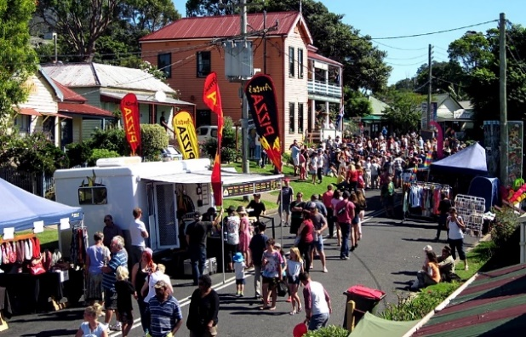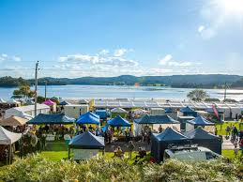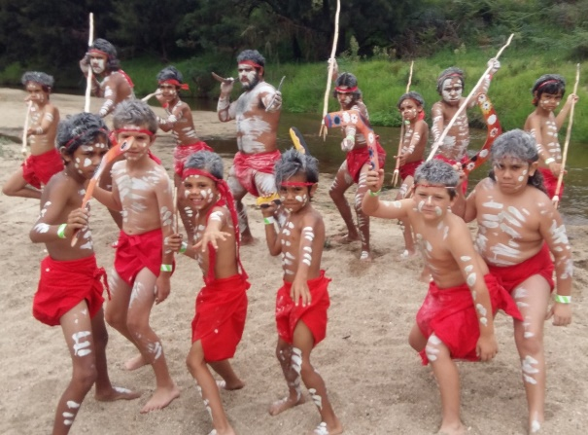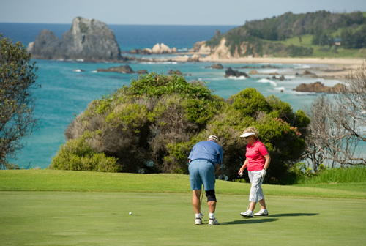

|  |  |
| --- | --- |
| C:\Users\scooper\AppData\Local\Microsoft\Windows\INetCache\Content.Outlook\ATQ8D4SD\Mud Map 2011_pullup.jpg |  |
|  |  |

# Our Investigations

We investigated a number of growth models and theories over the last few years, including ‘economic gardening’, an entrepreneurial approach to economic development that seeks to grow the local economy from within by supporting local businesses to expand, as well as ‘clustering’ which seeks to leverage the benefits of firms collaborating and competing across a location in a single industry.

Our research also led us to a seminal piece of work, *Small Towns, Big Ideas*, which is a report developed by the University of North Carolina, School of Government and the NC Rural Economic Development Centre. The report evaluated the experience of 45 small towns (less than 10,000 residents) in the United States that had thriving local economies and sought to identify common traits amongst these communities that led to their economic success. This report identified the following seven key themes for small towns to thrive:

1. 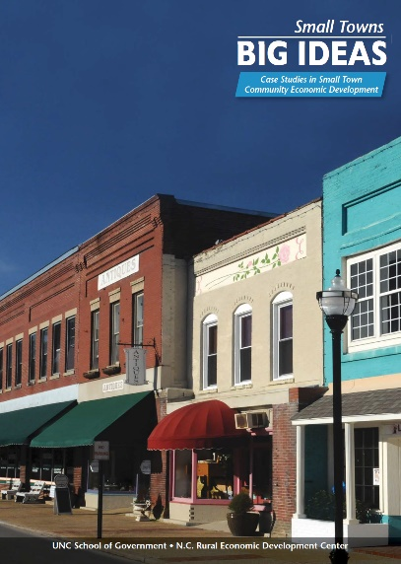In small towns, community development is economic development.
2. Small towns with the most dramatic outcomes tend to be proactive and future-oriented; they embrace change and assume risk.
3. Successful community economic development strategies are guided by a broadly held local vision.
4. Deﬁning assets and opportunities broadly can yield innovative strategies that capitalize on a community’s competitive advantage.
5. Innovative local governance, partnerships and organizations signiﬁcantly enhance the capacity for community economic development.
6. Effective communities identify, measure and celebrate short-term successes to sustain support for long-term community economic development.
7. Viable community economic development involves the use of a comprehensive package of strategies and tools, rather than a piecemeal approach.

We have adopted these seven key themes for our Community Plan.

**The difficulty lies, not in the new ideas, but in escaping from the old ones.**

* **John Maynard Keynes**

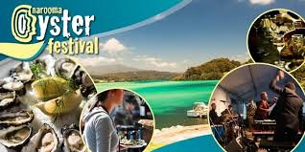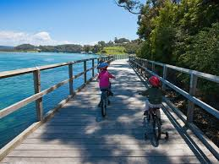

We have also investigated the broader, existing economic development strategies and plans. Our Plan aligns with and supports the outcomes highlighted in these strategic documents.

**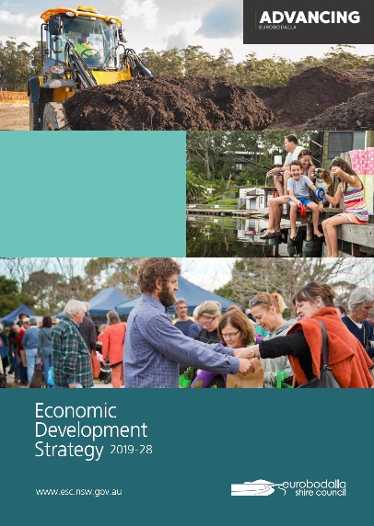**[**Advancing Eurobodalla: Economic Development Strategy 2019-28**](https://www.esc.nsw.gov.au/inside-council/community-and-future-planning/strategies/Economic-Development-Strategy)

The Advancing Eurobodalla Economic Development Strategy is the Shire’s plan for growing the economy over the next ten years. It incorporates many themes that are important to us and reflect many of our challenges (and opportunities).

The Strategy acknowledges the important role that tourism plays in the Shire’s economy but also highlights the need to diversify the economy. The Strategy highlights the need to broaden and diversify the tourism base as well as increase agriculture and food production, two areas where our district can contribute meaningfully to the Shire’s strategy.

**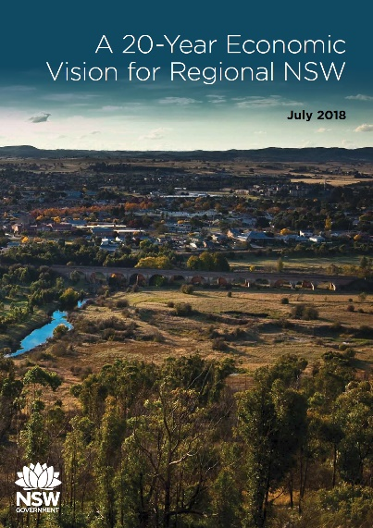**

[**A 20-year Economic Vision for Regional NSW**](https://www.nsw.gov.au/a-20-year-economic-vision-for-regional-nsw)

In 2018, the NSW State Government released its vision for regional NSW. The document identifies our district as part of the Far South Coast region. The vision highlights seven ‘engine industries’ that can drive the regional NSW economy forward over the next 20 years, which included Agribusiness and Forestry as well as Tourism, two specific areas where our district can contribute meaningfully to identified strategic outcomes.

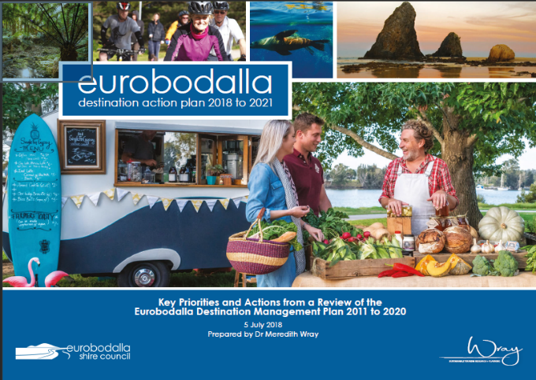

[**The Eurobodalla Destination Management Plan**](https://www.esc.nsw.gov.au/living-in/about/tourism/pdfs/Eurobodalla-DAP-5-July-2018-final-version-July-12.pdf) (EDMP) 2011 to 2020 established eleven key directions and associated actions to guide the development, management and marketing of tourism for Eurobodalla and its towns and villages.

|  |  |
| --- | --- |
|  |  |

# Community Engagement

This Plan is built and based on engagement with the community. It reflects the community’s ideas, thoughts and aspirations.

Across multiple years, a wide variety of discussions were held with individual community members about the need (and potential) for a Community Plan, about what it could mean and what it could (and couldn’t) deliver.

In 2019, two workshops were held in Narooma on 7th November and 22nd November that were jointly attended by 100 different local business owners, volunteers, community members and other stakeholders. These workshops were used to gather a collective vision and aspiration for the future of our district. During these workshops, we worked together and discussed the many strengths and weaknesses of our district, as well as our key opportunities and threats. We discussed a wide variety of initiatives and activities that we can undertake to achieve our shared vision and ensure that our district remains the special place that it is today.

The Shire of Eurobodalla participated in these workshops and a leading national expert in economic development was brought in to facilitate our discussions. From these workshops, we were able to clearly identify the future we want for our district as well as the actions we can take to ensure we get there.

**As community, we will take a proactive and leading role in the future development of our district.**

We declared that we are not willing to sit idly by as the world develops around us, but rather we will take responsibility for our own future fate.

**According to the research there appears to be a consistent theme, small town economic success correlates with our ability to collaborate within the community to solve problems. This includes the ability to stop thinking that we are competing against each other. It takes leadership and taking the time to get out and engage with the community. In small communities, people are always the most important resource!**

Our Community Plan has been created through the overall community engagement process and is based on input from community members.

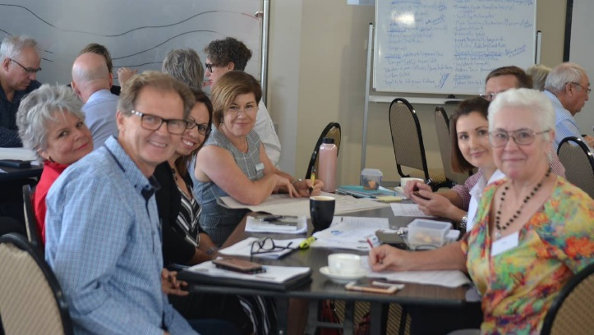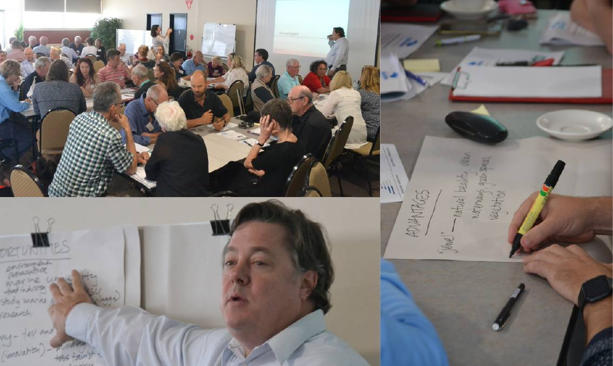

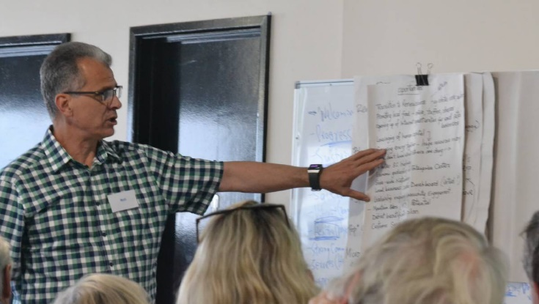

# Our Future

## Our Competitive Position

The following SWOT analysis was developed by the community and provides an assessment of our district’s overall competitive position. While many of the elements identified do not belong to the community and we can have very little influence upon some of these factors, combined, they form the basis for our future economic vibrancy and resilience.

**SWOT Analysis**

**Threats**

* Climate change
* Drought and bushfires
* Extreme and catastrophic events (fires, COVID-19)
* Narooma Bridge - potential danger of fatal accident
* Over development, environmental degradation
* Lethargy /apathy / complacency (she'll be right, mate)
* Potential future bypass
* Loss of the 'vibe', current lifestyle
* External competition
* Cheap overseas holidays (for tourism)
* Digital disruption
* Loss of young people out of the community

**Weaknesses**

* Lack of employment opportunities
* Lack of suitably skilled and motivated workforce
* Aging population
* Lack of education and health care services
* Distance to capital cities
* Lack of economic diversity, reliance on tourism (seasonal)
* Vacant homes, lack of rental accommodation
* Lack of mobile and high-speed internet connectivity
* Transport issues (bridge, overall access, lack of public transport)
* Lack of customer service (particularly for tourism season)
* Aging tourism accommodation stock
* Lack of tourism product/experiences
* Socio-economic disadvantage

**Opportunities**

* Indigenous tourism experiences and products
* Eco-tourism and Agri-tourism
* Diversifying industries with technology
* Mountain biking
* Waterfront/foreshore activities
* Additional festivals and events
* Luxury accommodation
* Redevelopment of Caravan Park on the Flat
* Creating a co-working and learning hub
* Business events
* Local agricultural produce and food processing
* Become a 'foodie' destination (provenance)
* Renewable energy
* Electronic vehicle charging stations
* Become leaders in customer service
* Community Instagram Account /YouTube Channel

**Strengths**

* Natural beauty / pristine natural environment
* Myriad of outdoor activities and pursuits
* Fresh seafood and high quality local produce that is accessible
* Rich Indigenous and non-Indigenous culture and heritage
* Local arts scene
* Festivals/events Narooma Oyster Festival
* Unspoilt, not over developed, coastal villages
* Strategically located (proximity to Canberra, halfway between Sydney and Melbourne)
* Lifestyle, relaxed and casual
* Safe and family friendly

## Our Vision

**We love our district. It is unique and special for so many reasons and we will protect our district and shepherd its ongoing evolution. In 20 years, we will become a model community renowned for a progressive economy, sustainable environment and a healthy happy community.**

## Our Principles

We believe strongly in the following principles, which will guide our actions in the implementation of this Plan:

* We will be **sustainable** and **protect the beautiful environment** that we are blessed with
* We will **work together cooperatively** to generate our future success
* We will be **empowered** and **together define our future**
* We **believe we have the power** to make a difference for future generations

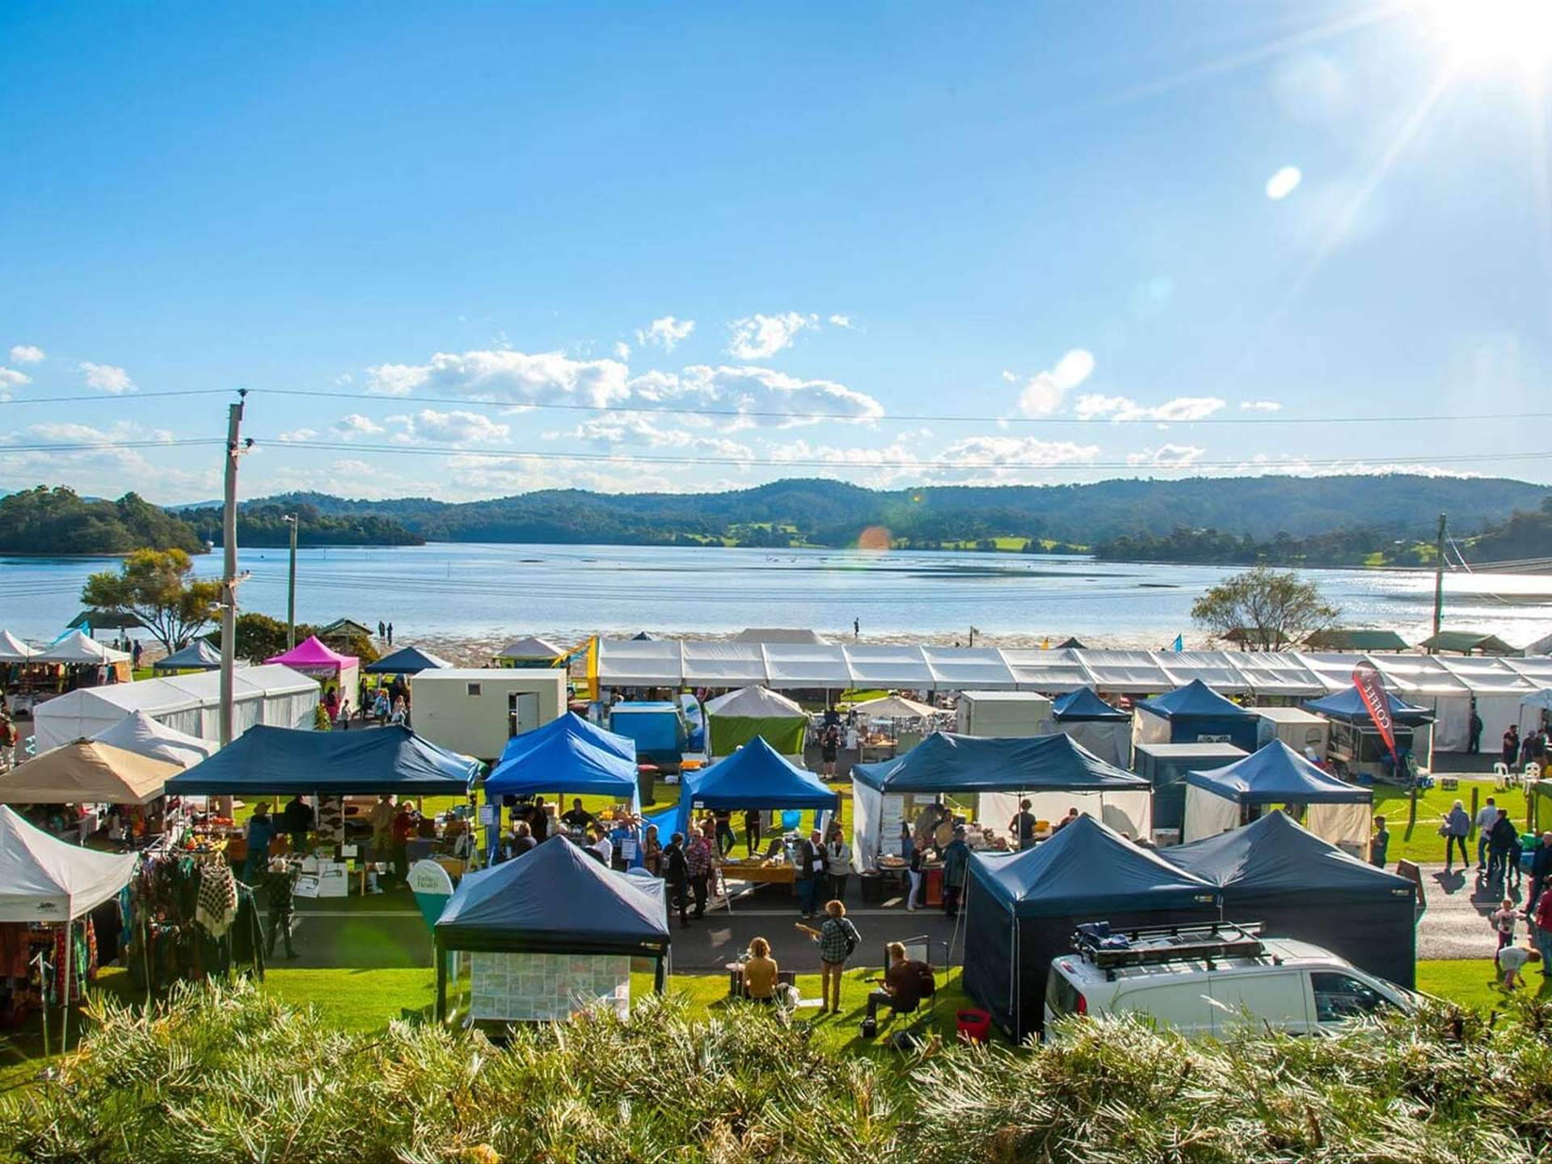

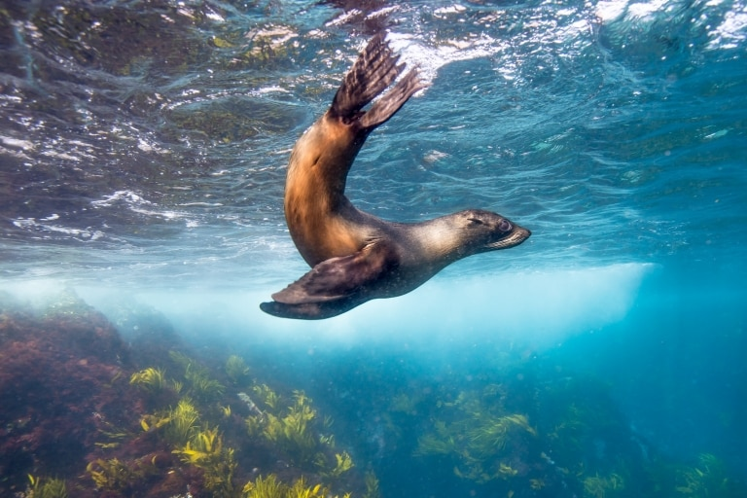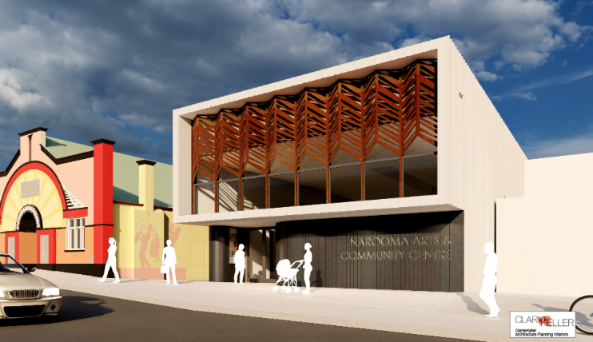

## Our Big Ideas

Beyond the opportunities that we have highlighted above, we have identified the following ‘big ideas’ that have the potential to bring considerable future benefits as well as act as a catalyst for future growth and vitality.

Our Big Ideas:

* **Enhancing Safety and Access**
  + **Addressing the Narooma Bar**: The community can provide an advocacy role in the future of the Narooma Bar. The Bar provides great challenges for many boats to navigate the entrance into (or out of) Narooma via water, creating a significant barrier for boating. Making the access to Wagonga Inlet easy for boats to traverse would create a new avenue for visitors to travel to and enjoy Narooma, opening an entirely new visitor market. Over time, once the Bar is fixed, the Narooma Marina would likely need to be expanded.
  + **Narooma By-Pass and Bridge**: a Narooma By-Pass has been discussed for over 50 years. It is a widely held belief by the community that the existing Bridge over the Wagonga Inlet provides a dangerous safety risk. Having freight trucks and caravans trying to simultaneously navigate the Bridge and the winding nature of the Princes Highway on the northern side of the Bridge is dangerous. The Bridge was not built with this type of traffic in mind, particularly the volumes of traffic that traverse the Bridge in summertime. Confirming a route of the by-pass that is agreeable to the community and addresses the safety issues would be the first step in addressing this issue. Once confirmed, funding should be sought for the project.

At the community workshops, there was strong support for the By-Pass route that follows a path west of the town of Narooma. There is no support for a ‘highway’ through the middle of town, even though this land use has been identified previously by the State Government.

* **Adventure Tourism:**
  + **Mountain Biking Centre**: A purpose built mountain biking centre would leverage our beautiful environment and bring a new visitor group to the district. The project would include the creation of a World Class mountain bike trail system suitable for all levels of riders. This would encourage not only local people but visitors to lead a healthy lifestyle and give different business and employment opportunities to the town.
* **Culinary Tourism and Food Production**
  + **Narooma Oyster Experience:** develop a new major visitor attraction, offering unique and immersive experiences working with the local oyster industry. Rock oysters are of particular importance to the South Coast including to the Yuin people. The project aims to revitalise Forsters Bay, the home of the annual **Narooma Oyster Festival**. The project would aim to educate visitors about oyster cultivation and its industry, the influence of the environment as well as the various oyster species and their flavour profile. The project would include a museum, tasting masterclasses, on water immersive experiences, and retail. A site in or around Forsters Bay needs to be identified for the building as well as various marine infrastructure, including a purpose built boat, to support this initiative.
  + **Developing a Cooperative Food Brand**: All of the producers in the district are small. While this small scale would normally be a disadvantage, by amalgamating together, across the myriad of different products, the variety of small producers can gain scale. Through common branding and amalgamating supply capability, local producers can gain greater and more direct access to markets, bulk purchasing and realise greater profitability. Often a strong, common brand can produce value for all producers and the region as a whole. This project would seek to provide an umbrella brand under which all producers could trade, which would provide bulk purchasing opportunities and deliver options for future growth.
* **Creating a centre supporting business growth, education and innovation (Narooma Hub)**: The Narooma Hub would be a purpose built centre to support business growth, education and innovation. The centre would provide opportunities for distance learning and connecting to a range of universities for local delivery of courses and specific content. The centre would also include a co-working space and provide access for businesses to access training, mentoring and other services to assist them to grow. It would also include a service offering to foster innovation and entrepreneurship as well as bespoke research using the unique and pristine environment in the district. The centre would be designed to also host a range of networking events and other functions to support business growth.
* **Promoting and enhancing cultural and artistic opportunity**
  + **Narooma Arts and Community Centre**: The Narooma Arts and Community Centre would be built adjacent to the Kinema and create a consolidated arts precinct in Narooma. The new centre would include three studios/workshops, a gallery exhibition area as well as associated catering, office and car parking. It would function together with the Kinema to offer a range of spaces for artists and could host a variety of traveling art exhibitions as well as a wide range of functions and events.
  + **Indigenous Cultural Experiences:** Umbarra Cultural Centre, Bush Tucker Walks,Indigenous Food Experiences, Aboriginal Cultural Tours…

Collectively (or individually), these projects have the ability to act as a major economic catalyst, providing diversity, vibrancy and sustainability into the community.

**One strong catalytic project can change the landscape, can have real impact and make a real difference for the future.**

# Our Plan

## Overview

The Narooma Community Plan is outlined in the following diagram. The Plan is directed by the vision and identified future aspirations of the community. The Big Ideas form aspirational projects of the community for which external funding will be required, but individually (or combined) can provide a significant catalyst for future growth and vitality. The Plan also consists of three key strategies:

1. Developing People
2. Developing Business
3. Developing Infrastructure

Under these three strategies a wide variety of initiatives have been identified by the community. As the community continues to evolve over time, the individual initiatives should (and will) change as they adapt to current market trends and the on-going evolution of our district, however, the structure of the overall plan will remain, providing overall direction for the next twenty years.

**Our District – Narooma Community Plan**



The following initiatives have been developed with the community to achieve the vision over time and contribute positively to the on-going development and evolution of the district. Various recovery initiatives have been developed for the immediate future, which are then supplemented by various short and long-term initiatives.

Through volunteers, the community has taken on many of the identified initiatives providing their time and any expenditure free of charge.

**Narooma District Community Plan Initiatives**

|  |  |  |  |
| --- | --- | --- | --- |
|  | **Phase** | **Timeframe** | **Stakeholder** |
|  | **Business Survival & Recovery** |  |  |
| 1 | Saving businesses through immediate financial assistance | 1-2 years | Govt/Banks/Businesses |
| 2 | Relaunch new Narooma District website | 1-2 years | Chamber |
| 3 | Create a buy-local program | 1-2 years | Chamber/Community |
| 4 | Collaborate on a local marketing strategy for tourism | 1-2 years | Community/Govt |
| 5 | Develop a coordinated and consolidated events calendar | 1-2 years | Community |
|  | **Developing local Tourism product** |  |  |
| 6 | Create a local Agri-food-tourism trail | 1-2 years | Community/Govt |
| 7 | Develop Indigenous tourism experiences | 1-2 years | Community |
|  | **Developing People** |  |  |
| 8 | Develop a customer service training campaign/challenge | 1-2 years | Chamber/TAFE |
| 9 | Create a local YouTube channel | 1-2 years | Community |
|  | **Developing Infrastructure** |  |  |
| 10 | Revitalise/beautify the town | 2-3 years | Community/Govt |
| 11 | Create structure for banners on street to promote events | 1-2 years | Community/Govt |
| 12 | Further develop local mountain biking trails | 1-2 years | Community/Govt |
|  | **Big Ideas** |  |  |
| 13 | Narooma Education and Business Hub | 2-3 years | Community/Govt |
| 14 | Mountain Bike Centre | 3-5 years | Community/Govt |
| 15 | Narooma Arts and Community Centre | 1-3 years | Community/Govt |
| 16 | Indigenous Cultural Experience | 3-5 years | Community/Govt |
| 17 | Narooma Oyster Experience | Long-term | Community/Govt |
| 18 | Developing a Cooperative Food Brand | Long-term | Industry/Govt |
| 19 | Major infrastructure Advocacy (By-pass/Narooma bridge, the Narooma Bar, Princes Hwy improvements) | On-going | Community/Govt |

|  |
| --- |
| **This process has demonstrated that we are a community that is optimistic about our future. We recognise that we need to harness this positive energy, trust ourselves and each other, divide up the work and progress forward.** |

## Narooma Community Plan Detailed Initiatives

### 6.2.1 Business Survival and Recovery

Due to both the bushfires and the COVID-19 lockdown, many businesses in the district have experienced significant cash flow difficulties and have had to resort to a combination of strategies to survive.

According to professional business advice – business can be supported by the following:

1) ***Staying abreast of support measures -*** such as government grants, JobKeeper program, ATO PAYG rebates, bank loan deferrals, new low interest bank loans, insurance coverage and other government or organisation business support programs

2) ***Re-think business model(s***) - and develop new strategies for revenue diversification

3) ***Revise operating budgets*** - with shorter time spans and fluid variables around available support, debt deferral, costs savings and realistic revenue forecasts

**Recovery Projects**: Due to the economic severity of both the bushfires and the COVID-19 lockdown it was decided that The Narooma and District Community Plan should take into consideration the enormous impact these two phenomenon have had on our local community. Moreover, the plan is due for revision after 12 months. Therefore, it was decided to incorporate an economic recovery component into the Community Plan.

The Narooma Chamber of Commerce has identified the following projects as priorities and therefore form the recovery component of the Community Plan. Several of these more achievable projects are already well developed and will be launched by the community in the coming months.

* Ensuring that local businesses are aware of both business support measures and the Community Plan recovery projects that are in development
* Re-launch the revised district web site
* Collaborate with all relevant stakeholders including ESC for relevant local marketing strategy for the district
* Create a buy local program
* Develop a coordinated and consolidated local events calendar

### Developing People

**Develop a customer service training campaign/challenge**

Customer services is important for the hospitality industry and for tourism, which is the key driver for the local economy. Australia is renowned for its lack of customer service and it has been demonstrated that good customer service will bring customers back and generate new ones.

This initiative is about delivering a local customer service training campaign for local businesses and staff to increase skills and experience. After the training campaign, Narooma will seek to deliver the highest levels of customer service in the country, which becomes the Customer Service Challenge. The Challenge will be tracked and measured through social media reviews of local businesses across major platforms (i.e. TripAdvisor and Facebook).

**Create a local YouTube channel**

This initiative seeks to celebrate all things Narooma. The channel will allow locals to film their experiences enjoying the area. The videos can then be shared through social media and drive traffic to the channel. Leveraging the strong networks of locals through their own social media platforms provides a strong consistent level of marketing and promotion of the area over consecutive weeks and months.

### Developing Businesses

**Create a local buy program**

The buy local campaign is not only aimed at locals’ spending money with local businesses, but would include local businesses being encourage to trade with each other. The program would also include events and tours of local businesses provides for other local businesses. Through this experience, local businesses will be able to share and learn from each other (as well as hopefully spending more locally).

**Create a local marketing strategy for tourism**

Like many of the destinations across the Eurobodalla Shire and the broader South Coast region, Narooma has its own unique character and appeal. Developing a specific, local marketing campaign focused on Narooma for tourism would make visitors more aware of the full offering of experiences and products in Narooma, which would assist to increase visitation to Narooma as well as the length of stay for visitors.

**Create a local Agri-food-tourism trail**

The district has a number of unique agriculture and food experiences. The region is blessed with a wide range of high quality agricultural and food products including Tilba Dairy, South Coast Oysters, local cheeses, local beef and much more). Additionally, there are a number of businesses that use this local produce, including restaurants, cafes and a new brewery. This trail would provide the visitor with a structure manner in which to not only enjoy the local products but also engage with local producers.

**Develop Indigenous tourism experiences**

The Traditional Owners of this land, the Yuin people, have a rich cultural history that remains alive and well. Local Indigenous tourism experiences could include bushwalks to explore Indigenous bush tucker (also could be included in the agri-food-tourism trail above). Other experiences could include story-telling, ceremonies, star-gazing, trekking or other tours that told the story of the land and its meaning.

**Develop a coordinated and consolidated events calendar**

Narooma has plenty of events. Given the nature and number of events, sometimes the planning for these events takes place in relative isolation, which can cause conflict with other events. In order to maximise the future benefits of events, a coordinated and consolidated events calendar will be put together. In this way, events can be planned on dates that do not provide conflict with other events or any of the peak tourism season times.

### Developing Infrastructure

**Revitalise/beautify the town(s)**

This project would include the opportunity to revitalise and beautify the town(s) including new signage, painting of buildings, redeveloping shop fronts and public spaces. Increasing the attractiveness of the town(s) will help to provide a more inviting experience for visitors and future residents.

**Create structure for banners on street to promote events**

The events calendar in Narooma is busy. Given the town’s location directly on the Princes Highway, the town receives a large volume of through traffic from visitors travelling up or down the coast. Given the layout of the district, visitors passing through may be unaware of an upcoming event. The creating structures that can attach to existing light posts and hold a banner that could advertise major events would help to inform this large and potentially unaware audience that would encourage them to stop. The structures would allow for multiple banners to be displayed throughout the year, depending on the up-coming event.

**Develop mountain biking trails**

Mountain biking is a significant growth market across the country. While there are currently some trails on offer in the region, the offering could be greatly expanded. This project is about developing (i.e. ‘cutting’) new mountain biking trails as well as providing some basic infrastructure (i.e. toilets, showers, lockers, etc.). Increasing the mountain biking offer in the district could create demand from a new type of visitor, which would diversify the existing visitor market.

**Consider development of local streetscapes (sculptures, seating, art)**

Ensuring that public spaces are inviting and attractive to visitors will help them to stay longer and engaged in these spaces. The more visitors are in public spaces, the higher the chance they will visit local businesses and purchase something. This project considers the local streetscapes in Narooma and how they could be improved through landscaping, adding various seating options, creating public art or sculptures or other ‘interesting’ things that would attract people (and selfies).

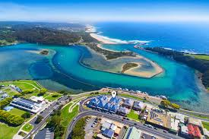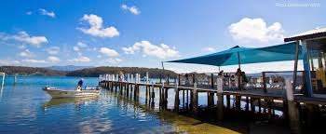

# Implementation

This plan will be implemented by the local community in collaboration with the local Council and other government entities. Project Champions have been appointed for many of the initiatives, who are responsible for progressing the project on behalf of the community and utilising the resources and other volunteers in the community as needed.

The Narooma District Chamber of Commerce and Tourism will be the vehicle for this Plan as the Chamber is already established, was heavily involved in the development of this Plan and provides an existing mechanism to support the implementation of this Plan.

A governing committee will be formed of local residents and business owners to oversee the implementation and evolution of this plan. The committee will meet quarterly to receive project updates from their project Champions regarding the progression of specific initiatives, identify any issues or hurdles or other areas requiring additional assistance. The governing committee may include project Champions and will have a major role in advocacy and supporting the project Champions.

Every year the community will review this plan to ensure it still represents their aspirations and the identified initiatives are attuned to current needs of the community and required changes and/or new initiatives can be added.

|  |
| --- |
| **This process has demonstrated that our community is a community that is optimistic about our future. We recognise that we need to harness this positive energy, trust ourselves and each other, divide up the work and progress forward**  **With the development of this plan, the Narooma Community has taken a power step forward, determined to define and dictate their own future. Through the implementation of this plan, the community will deliver broad economic and social benefits stemming from the initiatives identified. Through cooperative action, the Narooma Community will ensure its resilience and vibrancy into the future, over the short and long term.** |

“Not enough communities in Australia take it upon themselves to determine their own fate. Too often communities prefer to rely upon the local government or state government to be responsible for their development and vibrancy. It is very encouraging through the development of this plan that the Narooma Community has a different approach. They have come together to discuss the district (good and bad) and identify the most appropriate path forward. Furthermore, individuals have volunteered to work together and progress specific initiatives on behalf of the community. This is truly a unique model and one that should be followed by others in regional Australia.”

*-Michael Campbell, Lucid Economics*

Appendix A: Workshop Notes

**Narooma Community Plan – Workshop 1 (7 November 2019)**

This workshop was about investigating the community’s thoughts and aspirations for the future as well as investigating the area’s unique features and what can set it apart from others. The workshop began with an overview of various economic and demographic statistics for the district, which was followed by an in-depth discussion regarding strengths, weaknesses, opportunities and threats.

The economic overview has been provided as a separate report.

**Community Vision Brainstorming**

Community members were asked to describe in a single word or group of words how they would like to describe their community in 15 or 20 years’ time from today. Responses are captured below:

* Welcoming
* Progressive/Production Manufacturing Ag.
* Sustainable
* Inclusive /not exclusive/ Disabled friendly
* Safe (unlocked doors)
* Vibrant (Young/diverse)
* Healthy (physical, mental, spiritual, community)
* Strong Community (interlinked)
* Services (Health etc.)
* Prosperous
* Diverse (activities, retail, experiences) bus
* Transport (public) – Accessibility
* Education for Indigenous Culture
* Successful
* Jewel of the South Coast
* Still unique and beautiful (seaside character)
* Growth (population, visitors, business)
* Good infrastructure (communications, road transport, foot paths
* Managing adaptive Climate change (sea level rise)
* Small town character
* More tourism / ecotourism / increase accommodation / conference centre
* Employment Growth
* Financially viable
* Engaged / Public Art / Great places
* Balanced Business / Diverse Economy / Balanced Growth vs Environment
* Naturally Productive / Pristine
* Uncluttered (signage etc.)
* Modern town (Reminiscent of the past)
* Reputation
* Nature Oriented / Pristine
* Marina

**Our Strengths**

**Table 1**

* Natural environment beauty unique to us
* Family friendly, safe for kids, things to do
* Montague Island wildlife
* Not overdeveloped, “coastal village”
* Location and convenience of forested areas to the coast
* Weather 4th most temperate climate in the world
* Potential for multisport: cycling, kayaking, mountain walking, 4x4
* Potential as tourist district – close to other towns like Tilba, Bermagui, Bodalla
* Fishing
* Cycleway and boardwalk
* Seafood: fresh and local
* Diving
* Restaurant variety
* Arts: MACS and School of Arts

**Table 2**

* Unspoilt: lack of development, clean, pristine
* Location: Mountains and Sea, distance from city (halfway b/w Sydney and Melbourne, close to Canberra)
* Weather
* Lifestyle
* Town Aesthetics (planning)
* Visually attractive
* Historic: Tilba, Narooma, Bodalla
* Safe and secure
* Healthy
* World class diverse activities (diving, festivals, Montague Island, whale watching)
* Potential access to National Parks
* Environment – beaches, waterways, golf course, bush, clean water
* River Cottage TV series

**Table 3**

* Natural environment and diverse attractions (water, land, island)
* Low population beaches
* Pristine beaches
* Gulaga
* Indigenous culture, cultural tourism…VIBE
* Topography, restricted development potential but maintains unique coastal village feel
* Heritage value: Bodalla and Tilba
* Attractive to people on their second careers
* Growth in Health and Social Assistance sector
* Community resilience
* Positive thinking
* Community Soul
* Lifestyle
* Sea/tree change opportunity
* Free parking
* Visually stunning
* Kinema
* Affordable living
* Safe place to raise kids
* Family friendly
* Opportunities to Grow

**Table 4**

* JEWEL = Natural beauty, clean, waterways, green spaces, vegetation
* Need for growth but protect jewel
* Science and environment research – education (marine, whales)
* Redundant land (agriculture) used different
* Point of difference – pristine waters, landscape and valleys, base of Gulaga, Tilba
* Climate – comfort
* Niche produce – “paddock to plate”, seaweed forming
* Distinctly local – no chain foods
* Safe
* Lifestyle – active – “on holiday everyday”
* People are friendly, relaxed, laid back
* Calmness
* Known paradise – reputation
* Things to do – lifestyle
* Culture – Aboriginal narrative / history

**Table 5**

* Nature: geography, limiting development
* World class tourism assets
* Makes Narooma unique and beautiful
* Forestry and NPWS sustainable and well managed
* Montague Island has been well managed
* We are maintaining the natural landscape – not as accessible as some other coastal towns
* Temperate climate – great balance between convenience and pristine natural beauty
* Strong sense of community -many opportunities to volunteer. People care about each other and look out for each other’s children
* Community pride – talking up our district
* We market ourselves very well
* Locally grown food in our shops
* Wide variety of festival and events
* Opportunity to market food provenance

**Table 6**

* Culture and Heritage: Contribution to Community
* Nature and Untouched coastline
* Produce and Seafood
* National Parks and State Forests
* Proximity to NSW, ACT and VIC
* Unique Tourism experiences
* Community Passion
* Topography and waterways
* Lifestyle
* Birds and Wildlife
* Cycling and Walking paths
* Collaborative community
* Festivals and Events: Narooma Oyster Festival, Tilba Festival

**Table 7**

* Pristine water quality and waterway
* Relaxed lovely lifestyle
* Space
* Ease of Movement – no congestion
* Bush and Beach – nature – next to each other
* Walking tracks – pathways, bush trails, easily accessible
* Oyster industry
* Caring and friendly community
* Art and craft community very strong
* The Kinema
* Diverse Community: lots come from other areas
* Rich first nation heritage and first settlement history
* Golf course and facility
* Montague Island and tours and Gulaga
* Fishing, Whale watching
* Climate
* Water views – Many vantage points – not over developed
* No 3 storey buildings

**Table 8**

* No fast-food franchise (no litter)
* Local food: dairy, oysters, seafood
* Stunning views, waterways, nature
* Accessible beaches
* Events
* Mid-point: geographically Sydney – Melbourne
* Pristine
* Good Visitor Centre
* Climate
* Clean: Air, water, agriculture, aquaculture
* Limited high-rise

**Our Disadvantages**

**Table 1**

* Transport: Air, road local and tourism domestic and international
* Employment opportunities
* Tourism Infrastructure: Dalmeny Point, marine infrastructure, kayaks, seaplanes, cruise ships, helicopter landing sites
* Education – all levels
* Major accommodation brand
* Limited long-term rental accommodation
* Limited health services
* Aging population
* Cohesive Tourism marketing
* Land zoning: limited land availability (could be an opportunity)
* Telecoms: - reliability online
* Nor enough festivals and events
* Limited beautification – main thoroughfares
* Lack of competition – increased cost of goods
* Distance from major cities
* Consistency of Tourism experiences

**Table 2**

* Town planning: 3 shopping districts
* Bridge and road access and footpaths into town
* Parking on the flat
* Not RV friendly parking and waste
* Hospital location (could be advantageous)
* Lack of tertiary education
* Ageing population
* Median housing income
* Narooma bar: ocean access for boats
* Public transport: Insufficient and poorly designed
* Reliant on Tourism – need diversified industry
* Distance from major centres/cities
* Getting a workforce – finding people willing to work

**Table 3**

* Seasonality
* Accessibility
* Low household income
* Large casual workforce
* Health infrastructure deficiency (hospital)
* Poor transport
* Poor retail availability
* High percentage vacant homes
* Ageing accommodation infrastructure (tourists)
* Economics of providing services to tourists (penalty rates)
* Education, lack of course offerings

**Table 4**

* Lack of employment opportunities, skills
* Bridge (bypass?)
* Health care – hospital + doctors + specialists
* Freight
* Costly air services (if not early bird tickets)
* More educational opportunities – TAFE – Uni
* Facilities for conferences (100+)
* Land release – commercial and houses
* Ageing population – decrease in number of volunteers
* Internet – Communications
* Rental availability
* Town fragmented (lacks a central hub)

**Table 5**

* Employment initiatives
* Business Operating hours
* No foreshore development
* Bar – limiting entrance/exit for boats
* Narooma bridge
* TAFE/Trade opportunities
* Customer service attitudes
* Professionalism
* Assistance from ESC for development
* Poor town planning
* Limited transport
* Car parking
* Ageing population

**Table 6**

* Low response / engagement / participation in youth employment
* Transport
* Broadband…getting there
* No Tertiary education facility
* Aged demographics
* High unemployment
* Low discretionary spend
* Low annual employment opportunities
* Lack of rentals

**Table 7**

* Quality of Accommodation – more required
* Lack of Transportation options (public & economic/business)
* 3 different commercial areas in Narooma – flat, midtown, Woollies
* Topography of Narooma
* Narrow base in economy
* Job security concerns
* Education pathways – career options (no uni, reduced TAFE)
* Lower socio-economic base / economy
* Seasonal economy
* Known for being a “cheap” holiday destination
* Customer service consistency
* Underutilised waterfront
* High percentage of unoccupied houses (holiday homes)

**Table 8**

* Remoteness – few hours too far
* Transport – lack of options
* Lack of housing – rental lack of supply
* Lack of land availability
* Lack of tertiary education and health facilities (24hrs medical services)
* Untapped technology – education / business
* Travel for medical/health services – Canberra
* Lack of advocacy for the region
* Local Council representation limited
* Affordability – unaffordable, “haves and haves nots”
* Welfare dependency
* Town fragmentation

**Our Opportunities**

**Table 1**

* Transition to Renewables – return, electric cars
* Promoting local food – oysters, truffles, cheeses…
* Opening up of Internet opportunities for small retail businesses
* Leveraging of human capital
* Garnering energy together – huge resources…many people don’t know what others are doing
* A better South Coast highway
* Economic gardening via Enterprise clusters
* Shire-wide networking
* Local business cluster dashboard (virtual?)
* Leadership inspired community engagement
* Mountain bikes (MTB’s) Potential
* District beautification plan
* Customer Service Excellence Model

**Table 2**

* Arts festivals and other festivals
* Gulaga – Tourism (storm)
* Mountain bike trails – Tourism
* Improving accommodation standard to take advantage of our visitation rates
* History of the area – Tourism
* Improve RV and caravan town access / signage
* Make it easy and comfortable to stop, toilet, coffee, access to water)
* Extend cycleway and improve overall experience
* Cultural Tourism
* Off peak experiences
* IT Opportunities – tech companies

**Table 3**

* Sow positivity
* Create shopping experiences
* Improve customer service
* Develop YouTube channel
* Create/build framework for a united approach
  + To training
  + Planning
  + Festivals
  + Marketing promo
  + Communications
* Educating the community on the value of supporting locally
* Tapping into resources
  + Natural
  + Built
  + People
* Business ambassadors / mentors
* Engaging community

**Table 4**

* Cruise ships visits from Eden
* Redevelopment of caravan park on the flat
* Agri-tourism and eco-tourism national parks, farm experiences, reception/conference/locations
* Native wildlife park
* Pet friendly accommodation
* Family friendly activities – kids club
* Maze
* Cycling tour from Narooma to Dalmeny - E-bikes rental
* Grey nomad incentives…Grey Nomad month? Festival?
* Creating better long vehicle parking
* 5 Star accommodation options - farm stay?
* More festivals and bigger (like Elvis week at Parkes)
* MTB trails / park

**Table 5**

* RESEARCH - Environment, aquaculture, marine, food industry
  + University, TAFE campus (like CSU in Wagga)
  + Study marine education, research
* Blue Economy: test and trial ideas
* Business hub (innovation): building skills, tourist experience, mentoring, business planning
* Bypass: plan quaint town, more unique, safer town, freight access
* Population growth with available land
* Sustainable land release
* Micro tourist experiences – niche local experiences – grouped experiences (personal experiences)
* Promotion/marketing – What Narooma is? What is on?
* Create job (s) coordinating place – “Narooma”
* Catering for ageing population -mentorship, story-tellers, shared experiences
* Museums / Cultural facility
* Preserve what exists

**Table 6**

* Historical – Geographical – Cultural – Maps Journeys and experiences
* TAFE training: Health, hospitality, events, tourism and trades
* Local Community radio
* Intermodal
* Activities on the foreshore
* Aquaculture businesses
* Car wash
* Kids Activities eg. Mini golf, zip lines
* Marina
* Quality oyster bar, seafood restaurants and eateries
* Tesla type parking
* Progress association
* Foreshore infrastructure / Business & activities
* Bypass
* Tap into key personalities eg. Tim Burke events
* Café / Hospitality Culture
* Coordinated Opening hours

**Table 7**

* Educational Hub (move primary school next to high school), build TAFE campus
* By-pass
* Waterfront tourism
* Extend walkways (Ringsland, Old highway
* Trends, take advantages of vegan, fresh produce, renewables
* Provide kids events (competition kite flying)
* Conference hub
* Pop-up weekend stands
* Music festivals, NATA Oval
* Events: Garden Expo, canoe/kayak, vintage music and cars, bush safari
* Christmas display
* Arts infrastructure – structures along pathways
* Mid-winter shopping fest
* Consistency of displays – showing off Narooma
* Landscaping plan
* Support local small business

**Table 8**

* Developing a borderless tourism strategy for the whole of the South Coast, and transport strategy
* Working smarter through developing business partnerships
* Communications plan about supporting local
* Develop a communications plan to leverage opportunities
  + Sharing information
  + Raising community awareness
  + Having a shared vision
* Better information sharing between local, council and state government agencies re: future plans
* Developing secondary education campuses city – country
* Maximizing existing assets
* Be the place people want to be

**Our Threats**

**Table 1**

* Climate change
* Sea level rise
* Fires
* Drought
* Extreme and catastrophic events
* Narooma Bridge – potential danger of fatal accident
* Over development, environmental degradation
* Lethargy /apathy / complacency (she’ll be right, mate)
* Potential future Bypass
* Loss of the ‘vibe’, current lifestyle
* External competition
* Other regions in general
* Cheap overseas holidays (for tourism)
* Digital disruption, online shopping and competition from cheap, overseas products/services bought online
* Loss of young people out of the community

**Table 2**

* Climate - Sea level rise, fires, extreme and catastrophic events
* Bypass - routing? cost?
* Narooma bridge - design and capacity
* Changes to fishing stock - climate?
* Venice effect - sustainable tourism
* Over development - vegetation impact, aesthetics
* Lethargy / apathy / complacency… (we’ll be OK)

**Table 3**

* Rising Unemployment – anti-social behaviour
* Over-developed, unplanned growth
* Losing the jewel – environmental protection
* Lose uniqueness
* Aging infrastructure
* Climate change – rising sea levels
* Single access for emergencies
* Bridge bypass – where? What? Opportunity for planning in town with a bypass

**Table 4**

* Climate change – sea levels plan, water pollution, fires
* Drought affecting farmer visits from the west
* Bridge not being operational
* Cheaper overseas holidays (offering extras)
* Regional competition – Bermagui / Batemans Bay / Ulludalla / Jervis Bay / Merimbula
* Losing youth population – lack of opportunities
* Lack of consistency of experiences
* Caravan park on western side of flat could be a park, café, retail complex
* Loss of potential profitable festivals, markets, parkland with outstanding views
* Bypass??
* Community apathy / complacency
* Loss of small town feel and vibe

**Table 5**

* Climate change
* Unsustainable tourism
* Economy – currency fluctuation
* Business closures
* Narrow vision
* Bushfires – natural disasters
* Socio economic divide
* Racism
* Drug issue – lack of rehabilitation support
* Aging population
* Volunteers to support community organisations and events
* Politics between community groups
* Not doing anything – apathy
* Competition for tourist $$
* Not supporting locals
* Economy stalls (impact on internal tourism)
* Festivals to cease access to natural environment
* Disabled access to Services
* Lack of medical facilities (centralization of bigger towns)
* Lack of a diverse community (lack of people in 20-30s)
* Lowering birth-rate (Populate or die!)

**Table 6**

* Natural disasters – Fire
* Internet shopping
* Crime
* Angry old people
* Government regulations
* Pollution
* Loss of volunteers
* Other tourism destinations
* Events/Festivals (if they stop occurring or move to other towns)
* Poor town Planning (future)

**Table 7**

* Online products and services
* Infrastructure
* Inappropriate development
* Under-development
* Bridge closure (blockage)
* Bypass?? Highway and Clyde closure
* Economic Threats
* Floods and bushfires
* Government Policies

**Table 8**

* Sea level increases environment impacts – acts of God, storms
* Availability of volunteers and aging population
* Retail shopping (big towns take away from Narooma)
* Oysters and water pollution
* Bridge – major breakdown
* Nature destination - fire and storms (surrounded by water and bush)
* Local produce
* State policies – LEP – changes to destination
* Penalty rates - staff!

**Key Initiatives for the Future**

**Table 1**

* Business Hub and a paid coordinator (grant funded)
* Central calendar/register on Narooma.org.au inc information pack and contact details
* Dissemination of local information to key businesses to enhance customer service in the Narooma Tourism experience
* Branding: Farm door trails - Marketing Provenance

**Table 2**

* Consolidation of events information: Narooma.org.au – Facebook, community event calendar, information centre
* Beautiful town landscape
* Structures for banners: street lining, events upcoming
* Clarification of by-pass…community input
* Water side improvements

**Table 3**

* Hub for students undertaking courses (approaching schools)
* Marketing strategy for tourism, foods, business events
* Branding strategy
* Revitalising the town (landscaping, infrastructure)
* Business Partnerships

**Table 4**

* Business Case for a Southern Euro Community Coordinator facilitator (paid position through grants, sponsorships…
* Develop an Action Plan (vision, duties, aim to fund position)
* Set-up a Community Development working group – direct position of facilitator
* Events: busking to be kept in town

**Table 5**

* Setting short-term goals and long term goals: celebrate the wins
* Have regular forums to identify the action focus groups and monitor process
* Closed network group for communication
* Form focus groups to action particular goals. Need a driving force
* Draw up a plan. Delegate activities. Timetable of outcomes (KPI’s). Accountability, Flexibility
* Research similar towns that have successfully progressed and improved. “Borrow” their ideas
* Sponsorship? Grants for research
* Cohesiveness in the community. Agreement. Commitment. Collaboration

**Table 6**

* Focus groups areas
  + Marine research centre, need $$ and staffing
  + Cultural / historical tourism
  + Health and recreation wellbeing
  + Foreshore activities
  + Transport / Roads / opps
* Process Project Management: Research, inform consultant, plan, goals, measuring tools, Implement, Monitor
* Coordinate Business Initiatives and cohesive partnerships
* Research eg. Who-What-Why-When-Where-How

**Table 7**

* United approach to Tourism / marketing
  + Key group
  + Merged Chamber of Commerce (with Tilba)
  + To broader community
* Local buy Local
  + Target locals
  + Get community to support local
  + Work as a group rather than compete
* Communication between community groups to provide cohesion
* Paid person to coordinate. Need funding, be realistic

**Table 8**

* Community Events calendar (emails out, SMS updates, sports clubs, business events…)
  + Who builds it? Who updates it?
* Build Community spirit
* Designated Mountain Bike Trails
* Cultural Tourism Collaboration

**Narooma Community Plan – Workshop 2 (22nd November 2019)**

The purpose of this workshop was to review the findings of the first workshop and discuss how to take action moving forward to ensure the plan generated practical actions that could deliver tangible outcomes. Importantly, the workshop sought to identify how the community could deliver the Plan.

Through the workshop, the range of initiatives and opportunities were reviewed and prioritised. Additionally, Project Champions were identified in order to advance specific initiatives and an overall framework for implementing the Plan was discussed and agreed upon.

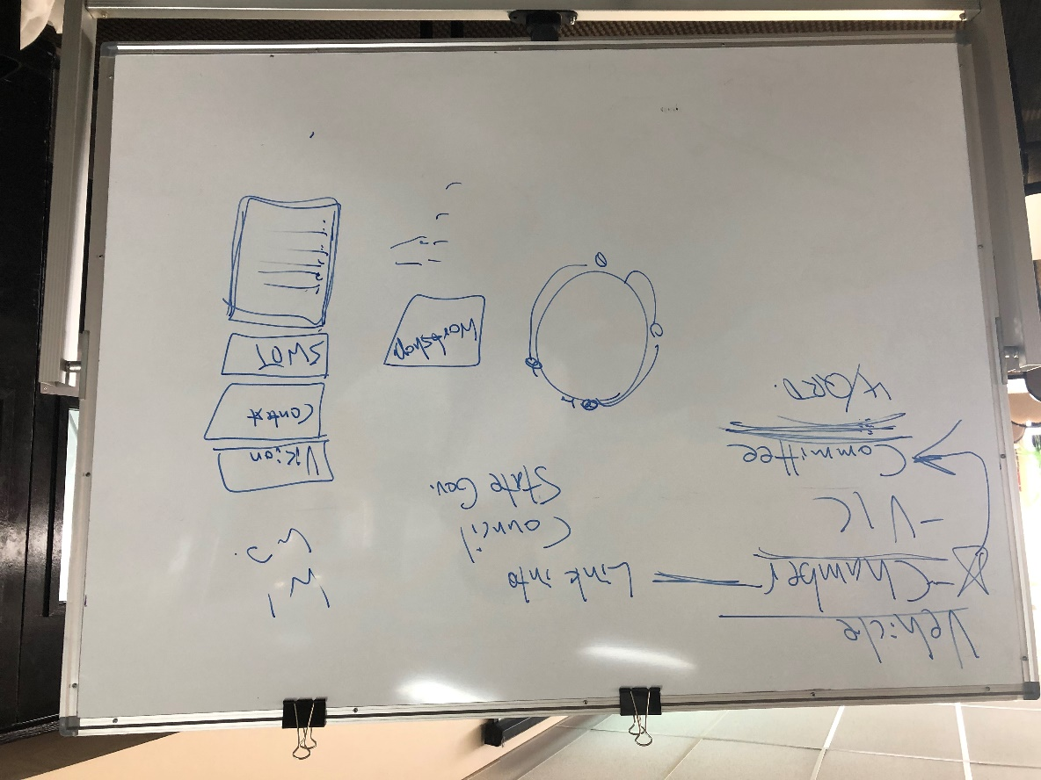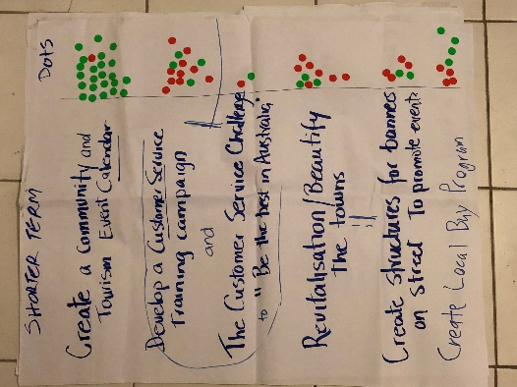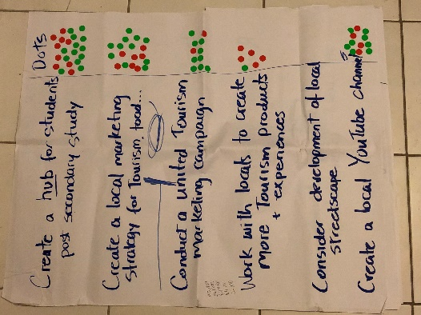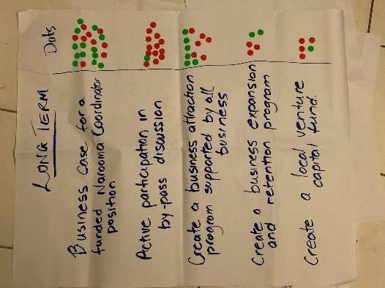

PAGE LEFT INTENTIONALLY BLANK